UNESCO HERITAGE SITES ITALY
Italy counts 55 UNESCO World Heritage Sites within its borders, the most of any country on the World Heritage List.

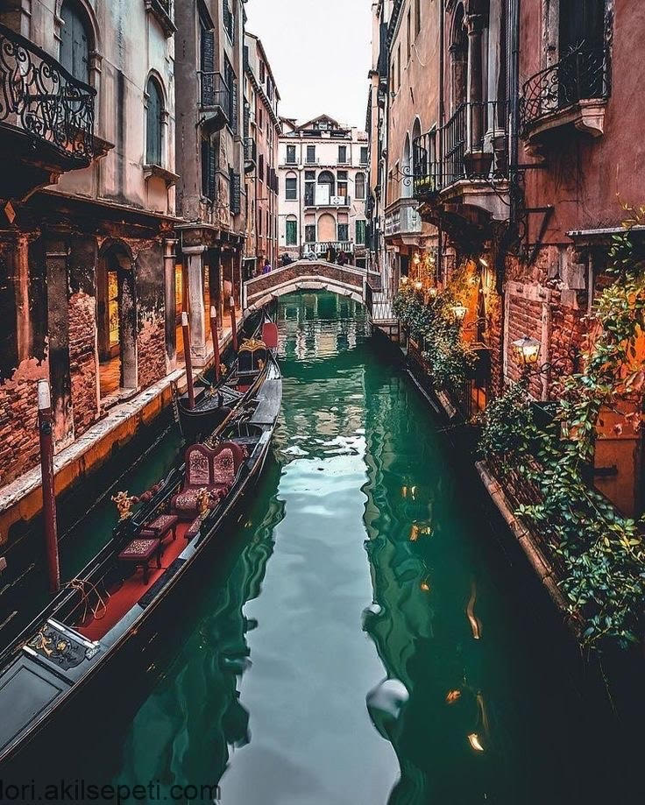
Venice and the lagoon

Venice was founded by the locals in V century to escape from the barbarians. The center of the city is articulated on the three islands of Torcello, Jesolo and Malamocco, but the entire city consists in 118 islands linked together by bridges and little rivers. During the Middle Age Venice was the most important and influent maritime city in Italy, thanks to the contacts with the East. Venice was also one of the first republics in Italy and an example of multicultural society in XII century. Great artists as Giorgione, Tiziano and Veronese were born there and Marco Polo sailed from Venice at the beginning of his journey to find China. Even Shakespeare chose Venice to set one of his comedies “The Merchant of Venice” and one of his tragedies “Othello”. Nowadays Venice offers to the tourists the view of its majestic lagoon, besides beautiful monuments as the Basilica of san Marco and the islands of Burano and Murano. Venice and its lagoon were added to the list of Unesco Heritage sites in 1987.

http://www.veniceandlagoon.net/webhttp://www.italia.it/en/travel-ideas/unesco-world-heritage-sites/venice-and-its-lagoon.html

HISTORIC CENTRE OF ROME
Founded, according to legend, by Romulus and Remus in 753 BC, Rome was first the center of the Roman Republic, then of the Roman Empire, and it became the capital of the Christian world in the 4th century. The World Heritage site, extended in 1990 to the walls of Urban VIII, includes some of the major monuments of antiquity such as the Forums, the Mausoleum of Augustus, the Mausoleum of Hadrian, the Pantheon, Trajan’s Column and the Column of Marcus Aurelius, as well as the religious and public buildings of papal Rome.

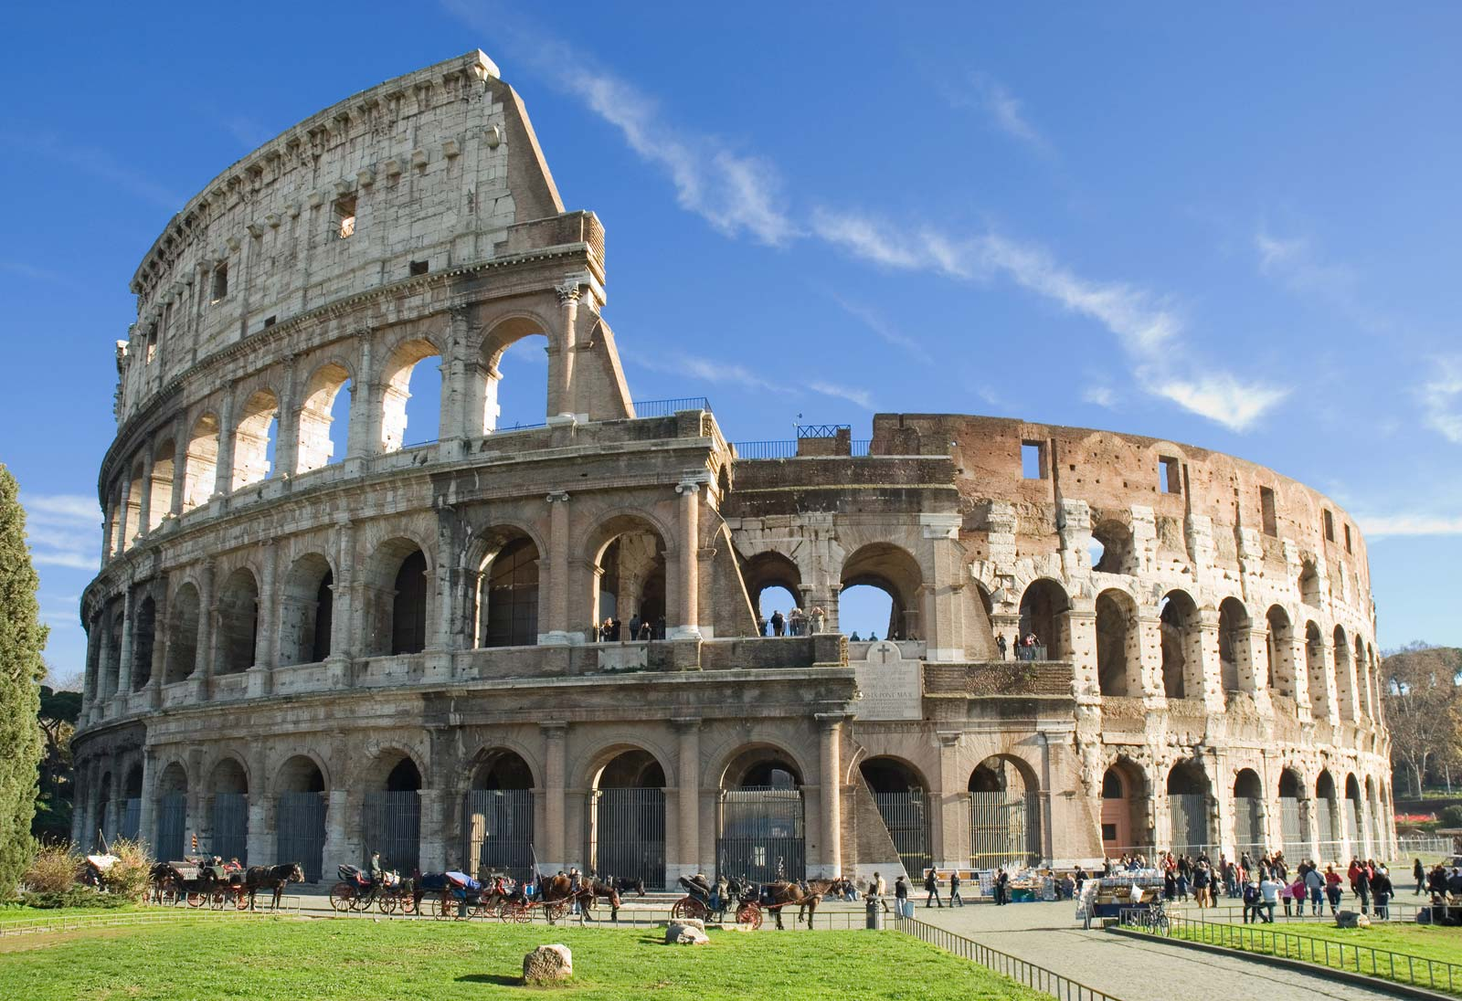

The Historic Center of Rome is probably one of the most significant, historical, and impressive world heritage sites in the world.
The most significant and recognizable location in Rome is the Colosseum which was recently named as one of the New Seven Wonders of the World. His construction began in the year 72 and it was finished in the year 80, during the empire of Titus. During the Roman Empire more than 50,000 people were allowed to enjoy shows, like gladiator fights or executions of prisoners, that took place in it.
The areas making up the World Heritage Site (extended, 1990, to include those walls erected by Pope Urban VIII) comprise some of the most important monuments in antiquity, among which the Imperial Forum certainly stands out. Not far, close to the Aventine Hill, we find two master works (that were also regular pasttimes for the gens romana): the Terme di Caracalla (212-217), exemplary of some of the most grandiose public baths; and the Circus Maximus, the ancient stadium used for horse and chariot races.
Numerous as well are Rome’s unforgettable piazzas: Campo de' Fiori, with the statue Of Giordano Bruno at its center, Piazza Navona, with Bernini’s splendid Four Rivers Fountain; the Spanish Steps (Piazza di Spagna) over which hovers the celebrated stairway; Piazza del Popolo and its characteristic “twin” churches; Piazza Venezia, almost imposed upon by the Vittorio Emmanuele Monument (the Altare della Patria, behind which lies the Campidoglio); the piazza Largo di Torre in Argentina that holds the remains of ancient pagan temples,
The Pantheon is one of the most notable tourist destinations in the historic center of Rome. It was a former Roman temple but is now converted into a church. The Pantheon’s construction was commissioned for by Augustus during his reign. However, it was Emperor Hadrian who saw the completion of the Pantheon. Its particularity is to have a hole in the center of the roof.
https://everything-everywhere.com/uensco-world-heritage-site-68-historic-centre-of-rome/ https://www.romeing.it
https://www.rome.net

POMPEI
Pompei was ancient Roman city located near Naples in Campania, Italy, at the base of Mount Vesuvius. Pompeii, along with Herculaneum and many villas in the surrounding area (Torre Annunziata,Stabiae), was buried under 4 to 6 m (13 to 20 ft) of volcanic ash and pumice in the eruption of Mount Vesuvius in AD 79. The circumstances of their destruction preserved their remains as a unique document of Greco-Roman life. Pompei is a UNESCO World Heritage Site status and is one of the most popular tourist attractions in Italy, with approximately 2.5 million visitors annually.

The town was started around the year 600 BC. It was started by a group of people from central Italy, the Osci. They chose to start it in this location because it was already an important location for trade by both land and sea. By the 5th century BC, Pompeii had become part of Rome. While under Roman control, Pompeii was improved a lot. The Romans built Aqueducts, and these were used to provide the citizens with water.

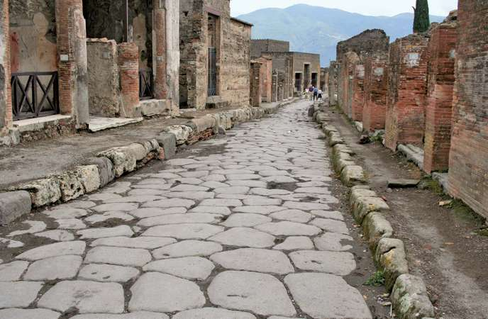

The terrible eruption in AD 79 largely preserved under the ash Pompei almost exactly as it had been almost 2000 years ago, the excavated city offers a unique snapshot of Roman, provides outstanding information on the art, customs, trades and everyday life of the past.
The city has re-emerged from the darkness of centuries precisely as it would have been when it was unexpectedly buried in the thick layer of ash and lava which poured down from the devastating eruption of Vesuvius. The scale of the tragedy was appalling: in what had been one of the most active and splendid Roman centres, life came to a permanent standstill.
The thick layer of volcanic material which submerged it, made up to a large extent of ash and lapilli - non-hard material, unlike that which covered Herculaneum and which solidified into extremely hard stone -has meant that the city has remained intact until the present day, not only as far as its buildings are concerned, but also as regards the contents inside the houses and shops, providing an absolutely fascinating picture of "daily" life.
The walls of the houses are covered with electoral propaganda messages or risque jokes aimed at particular citizens. The signs on the shop doorways indicate the activity carried out there or the name of the owner. Alongside the elegant villas belonging to the nobility and the luxurious residences of the middle class, stand modest houses where several families lived.
The peasant dwellings on the other hand are situated around vegetable gardens or small plots of land. On the edge of the city stood the brothels, squalid rooms intended as places of pleasure for sailors and travellers passing through, in the narrow lanes, the workshops and utility rooms provide further evidence of the daily routine performed by workmen and slaves as well as the women of the house. The houses still contain furniture, ornaments, gold and silverware, work tools, kitchenware, bronze and terracotta lamps, foodstuffs of all kinds, counters for serving drinks, grain mills and grindstones, workshops for manufacturing cloth, smithies and outlets selling groceries, fruit and vegetables.
There is a remarkable record of Roman painting, of which, without the finds made in Pompeii, virtually nothing would be known.
The architecture and development of the various types of houses is also amply documented. Thus the excavated city provides outstanding historical evidence of Roman civilization: these reminders of the past, which are so vivid and tangible in the remains brought to light, contribute to the fascination of the present
Pompei is a UNESCO World Heritage Site status and is one of the most popular tourist attractions in Italy, with approximately 2.5 million visitors annually.
http://www.italia.it/en/travel-ideas/unesco-world-heritage-sites/pompeii-herculaneum-and-torre-annunziata.html
https://www.pompei.it/pompeii/history-pompeii-excavations.htm

DOLOMITES

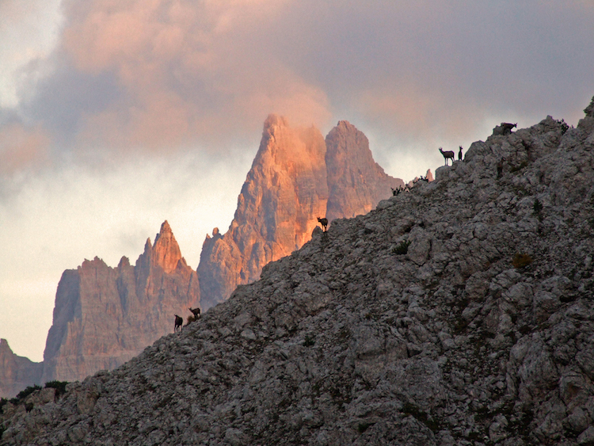
The site of the Dolomites comprises a mountain range in the northern Italian Alps, numbering 18 peaks which rise to above 3,000 metres. It features some of the most beautiful mountain landscapes anywhere, with vertical walls, sheer cliffs, deep and long valleys. A serial property of nine areas that present a diversity of spectacular landscapes of international significance for geomorphology marked by steeples, pinnacles and rock walls, the site also contains glacial landforms and karst systems. It is characterized by dynamic processes with frequent landslides, floods and avalanches. The property also features one of the best examples of the preservation of Mesozoic carbonate platform systems, with fossil records.
Weather can change abruptly in the Dolomites. Autumn generally comes early with frost present as early as late August. People flock to the region to see the explosion of color that the fall foliage, before winter blankets the landscape with snow that may not melt until late spring. Summers are short but beautifully lush and green.
There are also many activities to do, for example it is possible to ski and snowboard spectacular slopes, tackle a Via Ferrata climbing route, take a drive on the great Dolomites road, or practice downhill on a mountain bike.
The site was declared Heritage site in June, 26th, 2009.

https://www.guidedolomiti.com/en/dolomites-unesco/
https://www.dolomitiunesco.it/en/
https://www.altabadia.org/en/italian-alps-dolomites/alta-badia/the-dolomites-unesco-world-heritage.html

